
Directive:
The South African School Administration and Management System (SA-SAMS), is designed for the South African Education Sector and is maintained by the Department of Basic Education (DBE), ensuring that it is aligned to education policies. This aims to assist schools with their own data administration and reporting and ensures standardised implementation and reporting across all provinces.
SA-SAMS is updated quarterly with requests received from users and various policy owners. Changes are only included after being tabled at the National EMIS Technical Committee with membership from all EMIS provinces for recommendation. The new version is only released after being tested by EMIS sections as well as the policy owners. Changes on SA-SAMS are approved and signed off by EMIS in all provinces as well as the relevant policy owners.
The changes are audited by Internal Audit Services and the usage of SA-SAMS for reporting by schools as well as the data submitted is audited annually by Auditor-General of South Africa (AGSA) as part of the audits of national systems.
Release 21.2.1:
Version 21.2.1 is updated in response to Circular S18 of 2021, Examination instruction no 45 of 2021 and Circular NA 3 of 2021.
These amendments have a direct impact on the calculation of the School Based Assessment (SBA) marks for the Grade 12 LO and Dramatic Arts and the confirmation and/or promotion adjustment of all Gr 4-9 learners.
The quality assurance and testing was done by the Exam, Curriculum and EMIS sections as well as the PED’s to ensure alignment of the SA-SAMS Curriculum version. This is to ensure uniformity across the country and assisting schools and the sector with reporting.
Schools must ensure that this version is installed on their computers to assist with their administration and reporting.

Disclaimer on promotion function
***Please note that a system is programmed with rules that computes and results – it does not promote, fail or progress a learner.

The computed result is also based on correctly captured learner scores that were verified by the subject educator and subject head.

It is the accountability of the SMT at the school to reflect the computed result on 12.7.18 and then with consideration either endorse the promotion decision or amend it – capturing the reasons.

The Promotion schedules (12.9.15) and learner reports (12.7.19) will reflect the decision.

All schedules need to be printed and signed off by the SMT.

Changes for Version 20.2.1 & what schools must do:

Description | Screen | What is new / changed | Action by the school
- Update SBA calculation for Gr 12 LO and Gr 10-12 Dramatic Arts | 12.3.11  12.3.12 | - Gr 12 LO Task 6 marks changed to 80 and tasks 1-5 (SBA) changed to 320  - Gr 10-12 Dramatic Arts: Removed PAT in Term1 from SBA | - SBA updated by system, open 12.3.12 and print mark sheet  - For Gr 12 LO and Dramatic Arts - transfer marks to exam schedule, verify transferred marks
- SA-SAMS version added on mark sheets | 12.3.12  12.7.15 | - SA-SAMS version is printed on the top right corner | - Printed mark sheets will show the SA-SAMS version to assist with monitoring that correct version was used
- Page print wastage corrected when printing Quarterly schedules | 12.7.15 | - Additional empty pages print wastage corrected
- Quarterly schedule 12.9.15.7 column increased for more subjects | 12.9.15.7 | - Quarterly schedule can be printed for up to 50 subjects on one page
- Email function fixed |  | - Schools can mail learner reports to email recipients (request for 2022 to add option mail to all)
- SBA weight % fixed for reported IEB Gr 10-12 subjects |  | - SBA weight % fixed for following Gr 10-12 subjects:  Maritime Economics, Equine Studies, Maths P3, Nautical Science, Sport Sciences, Royal Schools, Practical Music examinations for Royal Schools, Trinity College and UNISA Gr 7 | - On 12.3.11 school to check and update SBA Weight %
- SBA:EXAM 60:40 fixed for Marine Sciences |  | - On 12.3.11 school to check and update SBA Weight % | - On 12.3.11 school to check and update SBA Weight %
- 2021 Changed decisions for GET included in this version |  | - On 12.7.14 , 2021 GET changed promotion decisions are included for Promotion functionality on 12.7.18 | - 2021 GET changed promotion decisions are included for adjusted promotion decisions on 12.7.18  - Subjects within the 5% is printed in purple. Failed marks is printed in red.  - When changing the NP to P the reason for the changed decision must be selected  - The decision must be selected for General Comments as well as the mark be added e.g. 40 % for Mathematics, Social Sciences and EMS

Please feel free to contact the Provincial Province or contact the Provincial Province or send us a message dbesasams@gmail.com or Ramphele.M@dbe.gov.za or vanderwesthuizen@dbe.gov.za when reporting an error or require more information on SA-SAMS.

Kind Regards
The DBE SA-SAMS team

FAQ : The following are possible solutions if the schools experience problems

- Steps to capture marks:
Set up
  - 12.1.11 Select subjects for school,
  - 12.1.14 create subject groups, 12.1.15 assign subjects to learners 12.1.16 assign subjects to educators
Assessment administration
  - 12.3.11 verify weights and year marks, update dates and totals
  - 12.3.12 capture marks
  - 12.7.16.3 approve marks for schedule
  - 12.7.18 approve learner achievement decisions (failed marks in red ), when changing the promotion decision (NP to P) select the correct reason and select also for General Comments for it to appear on the learner report
  - 12.7.19 print reports
Reporting and analysis
  - 12.9.12, 12.9.15 (7) Promotion schedules
  - 12.9.13/14 learner ranking
  - 12.9.16 subject/ grade performances

- Changing the Promotion decision on 12.7.18
- Click on 12.7.18
- Change settings to “Marks” on the right hand side
- If need change the “NP” to “P” and select the reason on Deviation Comment
- Add the comment on “report general Comment” for the learner report. In case of Circular 3 add: 40% for (List the subject names
- Print Promotion Schedule on 12.9.15.7 and learner reports on 12.7.19
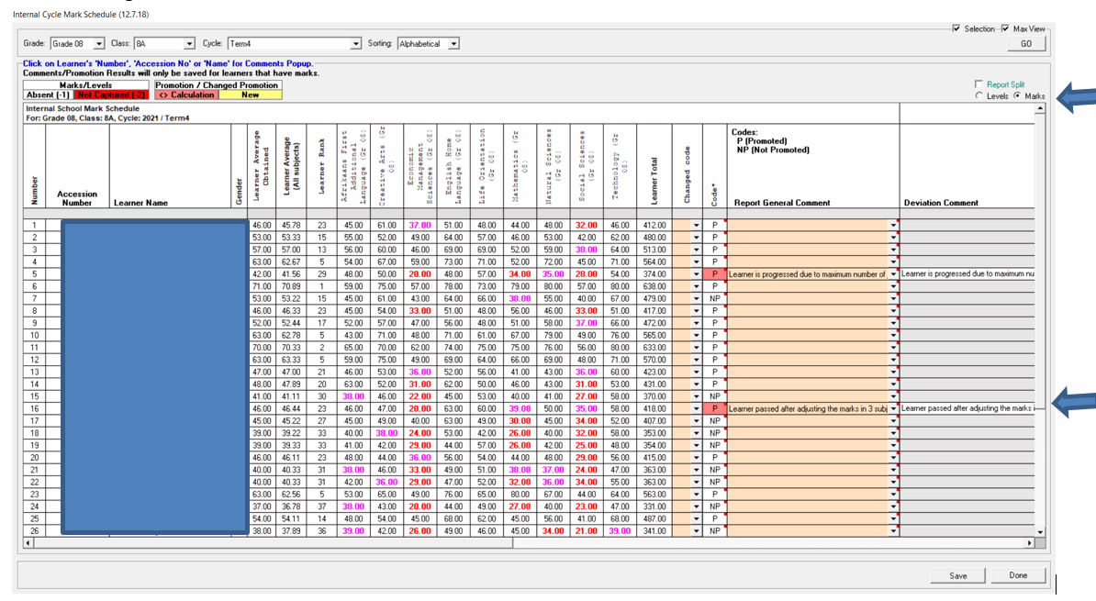

- Weight validation on 12.3.12

- Click on 12.3.11  - Check the SBA year mark at the bottom that it correctly reflects the new changes (if not see 3)  - Click on the yellow weight/validation-button | 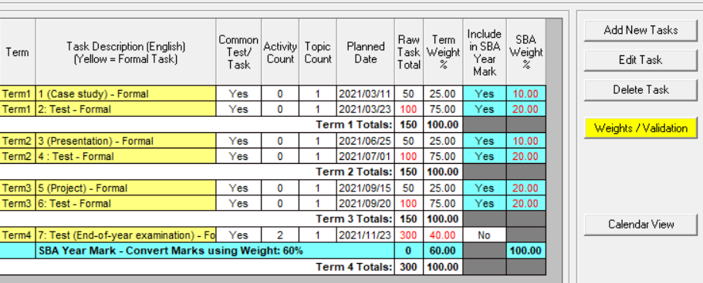
- If looks accurate click on Save/validate and then click on Done to exit the screen  - If there are changes to make, then  - Place the curser on the cell and change or  - Click on Auto calculate (e.g. this is when no SBA Weight % is showing) | 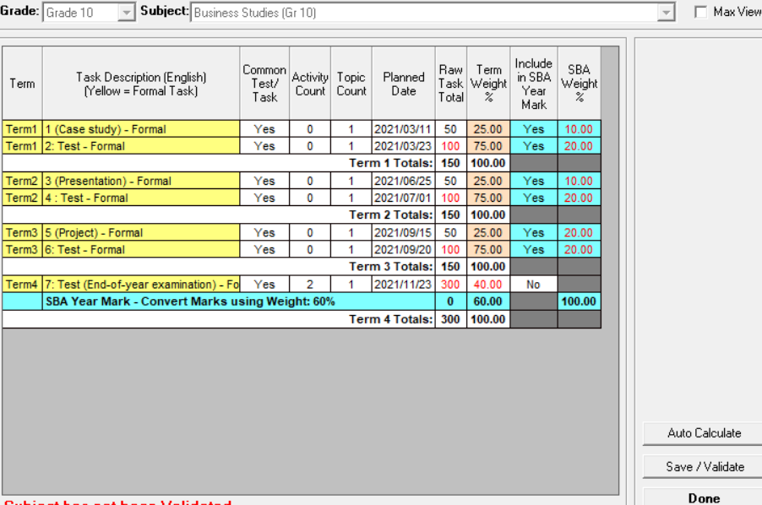
- The subject is then ready for capturing marks

- Checks for Term weights
When validating the weights check if the SBA year % is according to the grade, If not adjust follows:
  Grade | Weight% | Exceptions
  Gr R-3 | 100
  Gr 4-6 | 80 | LO (100)
  Gr 7-9 | 80
  Gr 10&11 | 60 | LO (100)
  Gr 12 | 75 | LO (100)
e.g. The blue line should read 60  Click on the blue line, then Click on Edit Tasks  Then change the weight % to 60 for this grade and click on save and then Done | 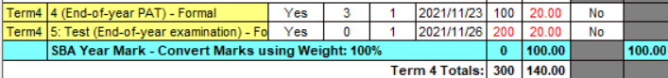  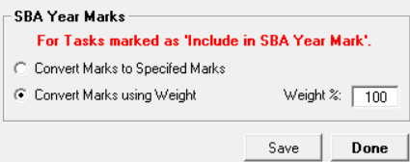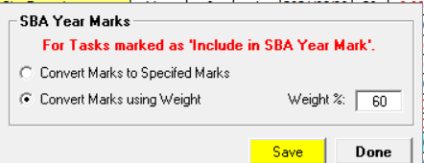
Continue with weight validations

