
Timetabling Assistant
This tip is designed to guide the schools with setting up the timetable using The Timetabling Assistant.
N.B:
Ensure that you have the teachers duty loads ready with the following information.
1. Name of teachers corresponding to names already captured on SA-SAMS.
2. Subjects attached to the teacher, class and number of hours in a cycle.
Instructions
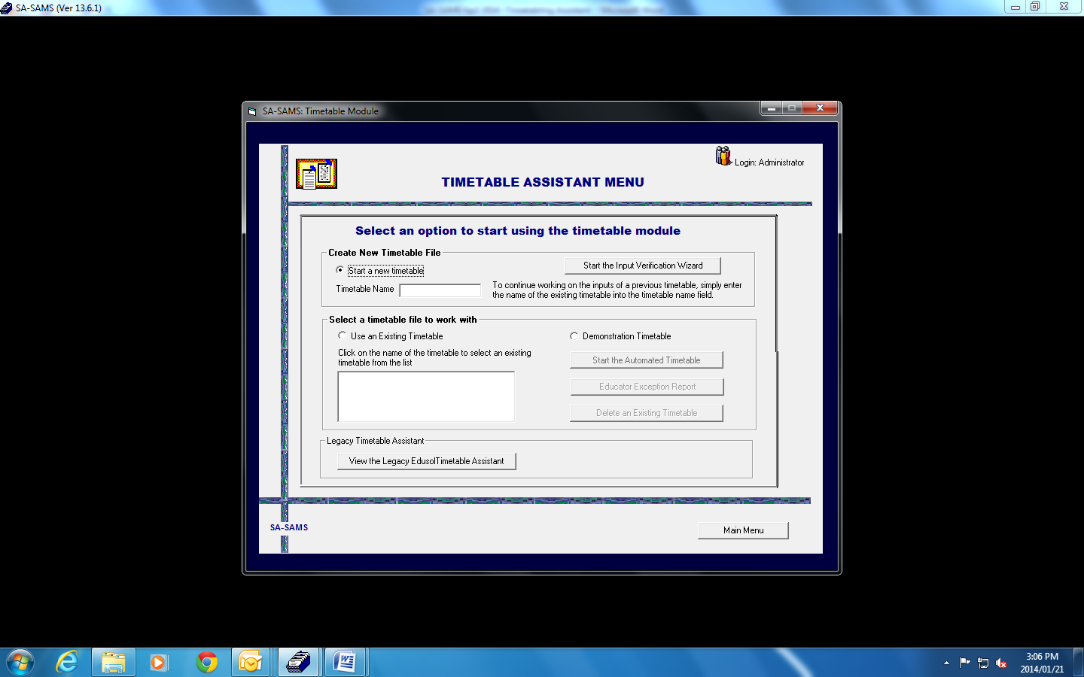 | - Navigate to Menu 13 and click on Timetabling Assistant and the Window on the left, will pop up.  - Select radio button Start a new timetable and give it a timetable name.  - Click on Start the Input Verification Wizard.
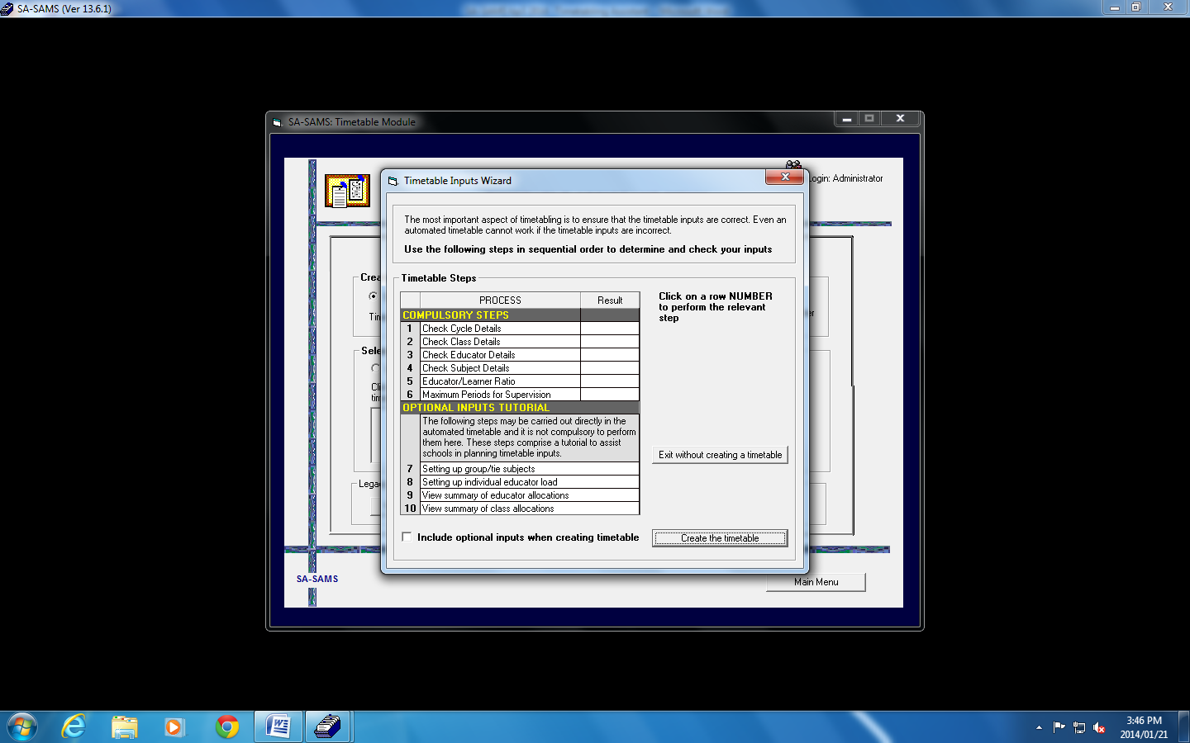 | - The window on the left will appear.  - Complete Compulsory steps 1 to 6 by following instructions.
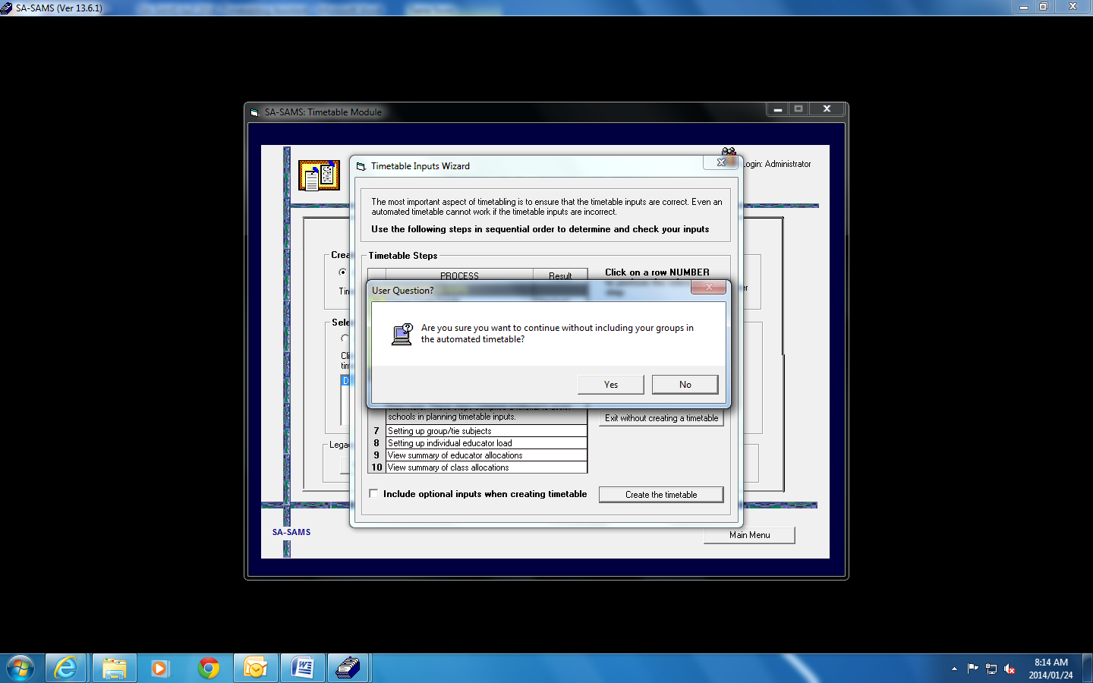 | - On completion of step 5 above, a User question on the left window will appear. Read the question and click Yes.
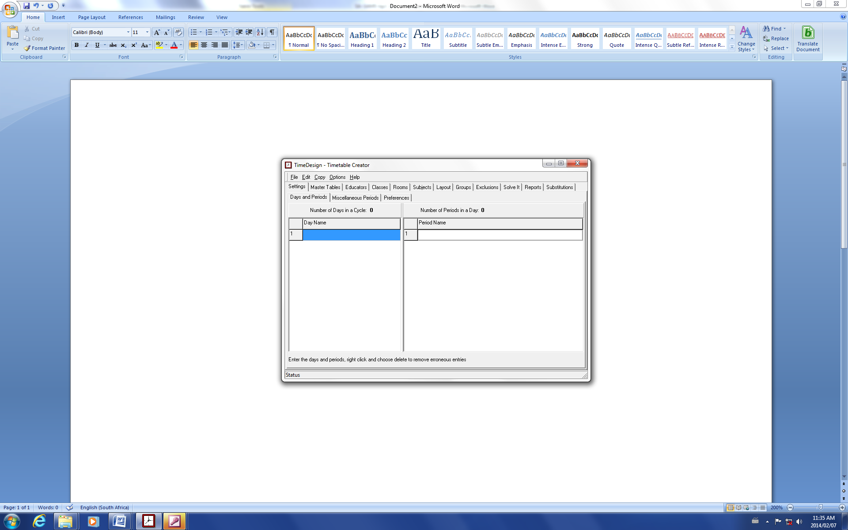 | - The Time Design –Timetable Creator Window on the left will Appear.  - Ensure that you complete each Tab with its SubTabs From Settings to Layout tab  - Spend more Time on the Layout Tab as this is the final capturing Tab before using Solve It to generate the final TimeTable Ready for Exporting to Excel.

To access a timetable that already exists:

Note: If your time table doesn’t show the Time Design-Timetable Creator window then check the following:
- That you are logged in as an administrator.
- GOTO Control Panel then User Accounts and click on user account control setting then the drag the scroll bar down to never notify me and restart your computer. Then your time table will work fine.

